Sleep Mode
- In Sleep mode, the clock frequency of the active peripherals is unchanged, but the processor and the memory subsystem are not clocked and therefore no longer execute code.
- Sleep mode is entered by the Cortex-M4F core executing a WFI (Wait for Interrupt) instruction.
- Any properly configured interrupt event in the system brings the processor back into Run mode. See “Power Management” on page 114 for more details in document spms376e.
- Peripherals are clocked that are enabled in the peripheral-specific SCGC registers when auto-clock gating is enabled (see the RCC register) or the peripheral-specific RCGC registers when the auto-clock gating is disabled. The system clock has the same source and frequency as that during Run mode.

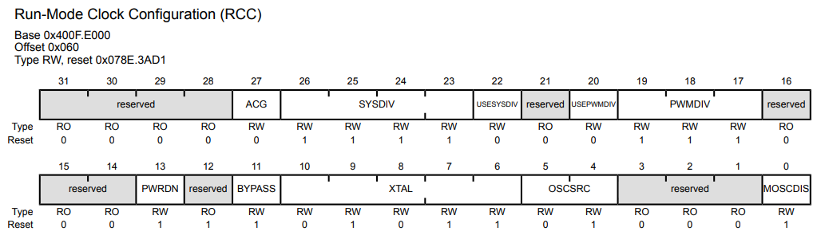
Run-Mode Clock Configuration (RCC)

Bit-27: Auto Clock Gate(ACG) - at reset Bit value is 0

This bit specifies whether the system uses the Sleep-Mode Clock Gating Control (SCGCn) registers and Deep-Sleep-Mode Clock Gating Control (DCGCn) registers if the microcontroller enters a Sleep or Deep-Sleep mode (respectively).

BIT 27- Value Description
- The Run-Mode Clock Gating Control (RCGCn) registers are used when the microcontroller enters a sleep mode.

- The SCGCn or DCGCn registers are used to control the clocks distributed to the peripherals when the microcontroller is in a sleep mode. The SCGCn and DCGCn registers allow unused peripherals to consume less power when the microcontroller is in a sleep mode.

Deep-Sleep Mode
- In Deep-Sleep mode, the clock frequency of the active peripherals may change (depending on the Deep-Sleep mode clock configuration) in addition to the processor clock being stopped.
- An interrupt returns the microcontroller to Run mode from one of the sleep modes; the sleep modes are entered on request from the code.
- Deep-Sleep mode is entered by first setting the SLEEPDEEP bit in the System Control (SYSCTRL) register (see page 166) and then executing a WFI instruction.
- Any properly configured interrupt event in the system brings the processor back into Run mode. See “Power Management” on page 114 for more details.
- The Cortex-M4F processor core and the memory subsystem are not clocked in Deep-Sleep mode.
- Peripherals are clocked that are enabled in the peripheral-specific DCGC registers when auto-clock gating is enabled (see the RCC register) or the peripheral-specific RCGC registers when auto-clock gating is disabled.
- The system clock source is specified in the DSLPCLKCFG register. When the DSLPCLKCFG register is used, the internal oscillator source is powered up, if necessary, and other clocks are powered down.
- If the PLL is running at the time of the WFI instruction, hardware powers the PLL down and overrides the SYSDIV field of the active RCC/RCC2 register, to be determined by the DSDIVORIDE setting in the DSLPCLKCFG register, up to /16 or /64 respectively.
- USB PLL is not powered down by execution of WFI instruction.
- When the Deep-Sleep exit event occurs, hardware brings the system clock back to the source and frequency it had at the onset of Deep-Sleep mode before enabling the clocks that had been stopped during the Deep-Sleep duration.
- If the PIOSC is used as the PLL reference clock source, it may continue to provide the clock during Deep-Sleep. See page 264.

Important: Before executing the WFI instruction, software must confirm that the EEPROM is not busy by checking to see that the WORKING bit in the EEPROM Done Status (EEDONE) register is clear.

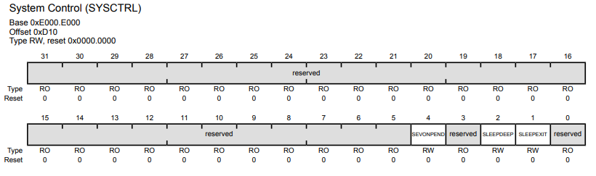
System Control (SYSCTRL) register (see page 166)

BIT 2- Value Description – DEEP SLEEP ENABLE/DISABLE

Value Description

0 Use Sleep mode as the low power mode.
1 Use Deep-sleep mode as the low power mode.

